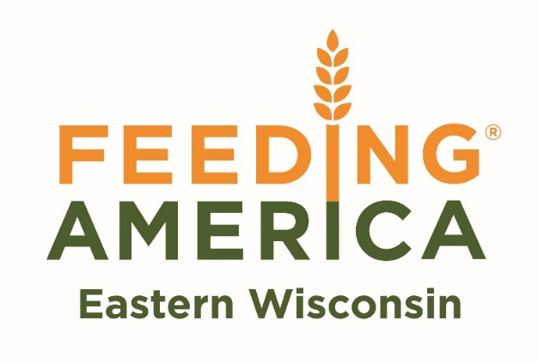

**SENIOR**

**MOBILE**

**FOOD PANTRY**

Hosted By:

**Date: Wednesday June 24th, 2020**

**Time: 11:00 am – 1:00 pm**

**Location: Village of Endeavor**

**400 Church St. Endeavor, WI 53930**

**What to Bring: Box or bag to carry food items**

Feeding America Eastern Wisconsin’s Senior Mobile Market Program works to assist seniors age 55 and over by providing healthy and nutritious foods in a farmers market-style distribution. Senior Mobile Markets are open to the public and provide individuals the choice to select from available foods that meet their dietary and personal needs, **FREE OF CHARGE**.

*Quantities are limited and will be given away on a first come, first served basis.

Limit one bag per household.